Requirements/Design Specification

**Capture Container Change**

Revision History

|  |  |  |  |
| --- | --- | --- | --- |
| **Date** | **Revision** | **Description** | **Author** |
| 10/09/2014 | 1.0 | Initial Version with Requirements | Roger Behm |
|  |  |  |  |
|  |  |  |  |
|  |  |  |  |
|  |  |  |  |

The information furnished herein by Republic Services Inc. is proprietary and confidential to Republic Services Inc. personnel and is not to be duplicated, published, or disclosed to any third party in whole or in part without permission from Republic Services, Inc.

© Copyright 2012, Republic Services Inc. - All rights reserved.

Table of contents

1 Business Requirements 6

1.1 Purpose of the Design Specification 6

1.1.1 Business Functional Requirements / Configuration 6

1.1.2 Technical Design Requirements 7

2 Assumptions 7

3 Technical Design 7

3.1 Referenced Documents 7

3.2 Process Flow and Mock Ups 7

3.3 Functional Logic 8

3.4 Data Sources & Mapping 9

3.5 InfoPro Interface 9

4 Report Changes 9

5 Technical Architecture 9

5.1 Infrastructure Considerations 9

5.2 Data Retention 9

5.3 High Availability 9

5.4 Backup, Rollback and Recover 9

6 Other Design Specifications 9

6.1 Build/Configure Standards 9

6.2 Policies and Procedures 9

6.3 Security Design 9

6.3.1 New or Existing Security 9

6.3.2 Hierarchal Data Access 9

6.3.3 Infrastructure 9

6.4 Environmental 10

7 Appendix 10

# Business Requirements

## Purpose of the Design Specification

This document outlines the change from assigning an EXC charge code for an “exchange” to a Removal and Displosal as InfoPro does. In order to properly align the proposal and invoice with regards to price and charge codes Capture will specify a DEL and REM for exchanges (ie customer wishing to move from and 6 to and 8 yard container).

### Business Functional Requirements / Configuration

| **Business Functional Requirement** | **Notes** |
| --- | --- |
| Config (Select Service Offering) page | No Changes. Scenario is limited to when a user changes the container size or waste type (larger or small). |
| Configuration Templates need to reflect cart related data if sold by that division. | Team leads will need to get the carts data from their divisions. |
| Commerce | * Remove the EXC charge code from the line item grid * Add charge codes REM and DEL to line item grid. * Zero out the REM price, but keep the floor/avg/target (issuing a credit) * Keep the standard DEL charge * Both prices should be editiable by the sales rep |
| Documentation   * CSA * Proposal * Sample Invoice | * CSA will display credits for REM and DEL in comments section as the EXC currently does * Proposal, display both charge codes with associated credits as normally would. (See screen shot below) |
| Approvals | * No changes |

### 

### Technical Design Requirements

| **Technical Design Requirement** | **Notes** |
| --- | --- |
| Config (Select Service Offering) page | Should not require any changes |
| Commerce | * Scenario will only be triggered for existing customers when a service change is specified and the size of the container has changed |
| Documentation   * CSA * Proposal * Sample Invoice | * Will need to specify Removal discount in CSA |
|  |  |

# Assumptions

* AAE will be modified to read both RM values and choose the RM on the line item grid
* The RM and DEL charge codes and line within the new container on the line item grid. I belive currently InfoPro applys the RM charge code to the old container group.

# Technical Design

## Referenced Documents

None

## Process Flow and Mock Ups

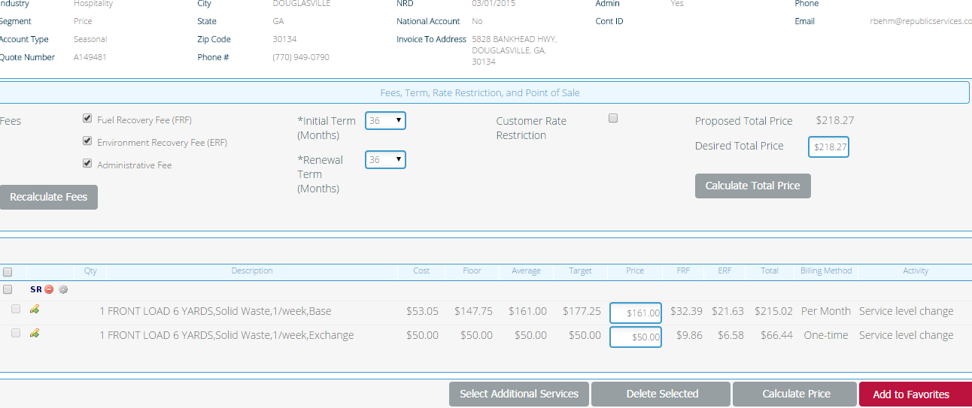

Instead of Exchange we will ad a Removal (priced as 0) and a Delivery. **will we need to bring in the old container and apply the $0 REM on it?

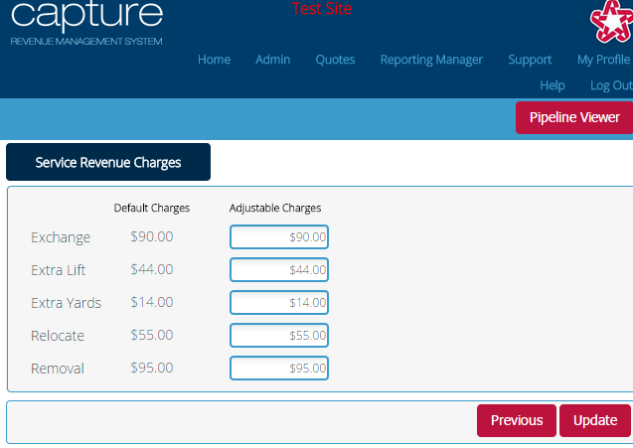

From an InfoPro perspective the RM charge code amount on the line item grid should override this SR values for removal.

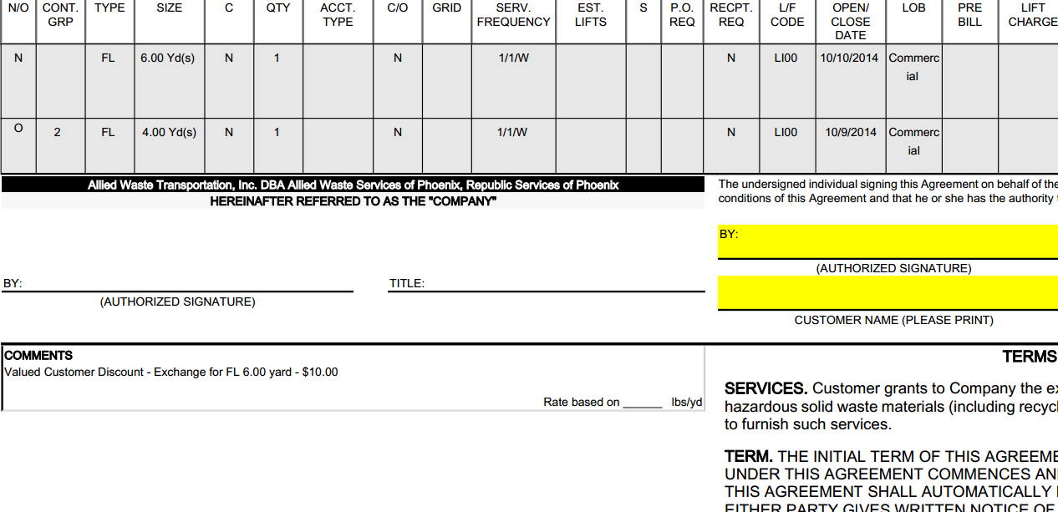

Instead of Exchange this will say Removal and possible Delivery

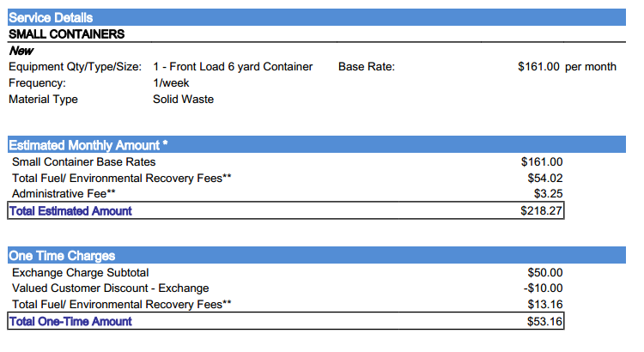

Instead of Exchange, Removal and Delivery will display

## Functional Logic

Use current container functional and pricing logic

## Data Sources & Mapping

* For detailed mapping information, please refer to the BMI [Enterprise Mapping Document](http://itpmo-2013projects/Pricing%20Initiative/2.0%20Planning%20and%20Requirements/BMI%20Enterprise%20Mapping%20Document.xlsx).
* No additional data sources or mappings needed

## InfoPro Interface

InfoPro will need to look at the both the RM charge codes. On the the SR popup page, the other on the line item grid. The line item grid takes presidence. We can add the XML code once the changes to the line item grid are made.

# Report Changes

No Changes

# Appendix

None